CN0503 GUI Quick-Start Guide
V1.0 – Initial Version

Resources and References
CN0503 Firmware Wiki: https://wiki.analog.com/resources/eval/user-guides/eval-adicup3029/reference_designs/demo_cn0503
CN0503 Hardware Wiki: https://wiki.analog.com/resources/eval/user-guides/circuits-from-the-lab/cn0503
ADICUP3029 Wiki: https://wiki.analog.com/resources/eval/user-guides/eval-adicup3029
ADICUP3029 Drivers and Drag & Drop Details: https://wiki.analog.com/resources/eval/user-guides/eval-adicup3029/tools/adicup3029_hw_drivers

INtroduction
The CN0503 Optical Liquid Analysis reference design provides a command-line interface for use on a terminal. In order to streamline the evaluation process, a python GUI and python scripts are also being provided. This document describes how to get running with the GUI. For basic assembly and operation of the CN0503, refer to the Resources and References section.
Note: GUI v1.0 does not yet enable calibration or direct data-logging. Data can still be exported from the graph utility or logged in a terminal program. For calibration, there is a separate Python script to walk through the process.

Getting Started
- Set up the hardware according to the hardware wiki. The default configuration installs the 365nm LED in LED1 (fluorescence), 430nm for LED2 (absorbance), 615nm for LED3 (absorbance), and 530nm for LED4 (turbidity).
- Plug in the USB and wait for the drivers to finish installing.
- Download the latest firmware hex file from https://wiki.analog.com/_media/resources/eval/user-guides/eval-adicup3029/reference_designs/aducm3029_demo_cn0503_hex.zip
Then unzip the archive and load the firmware hex file onto the device by dragging and dropping it to the DAPLINK drive.
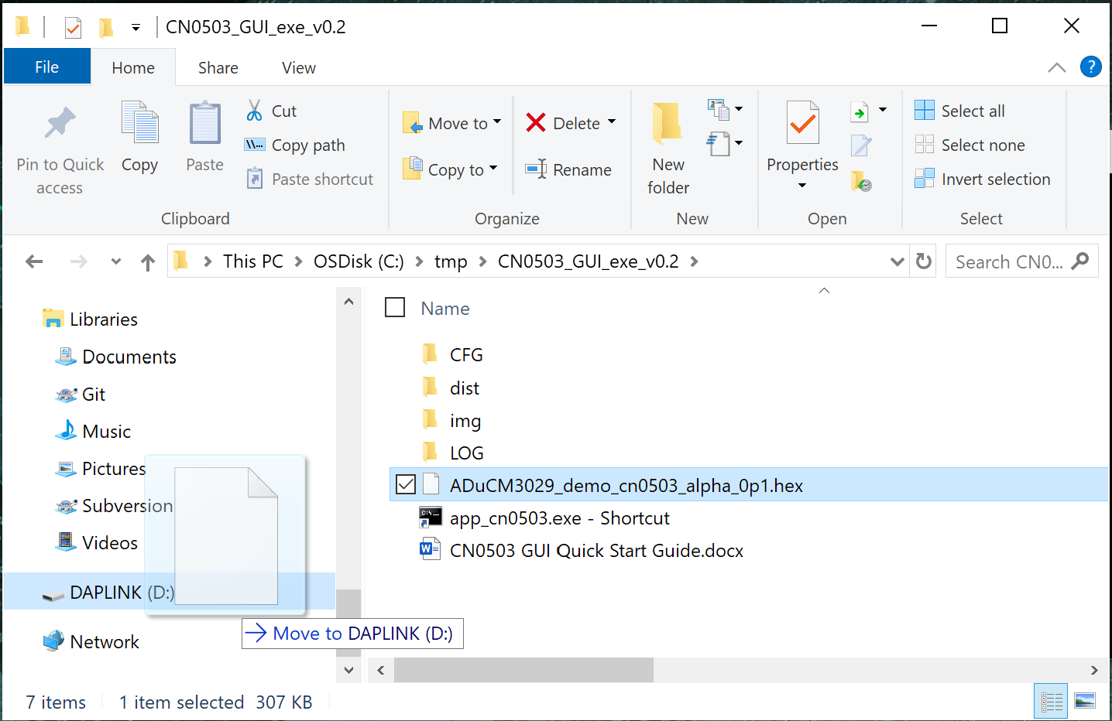
- After the file has finished loading and the DAPLINK drive reappears in the menu, cycle the power of the system by unplugging and re-plugging the USB. This starts the new firmware running.
- Open the GUI executable by clicking the shortcut to app_cn0503.exe or navigating to ‘/dist/app_cn0503/app_cn0503.exe’
  - The exe is provided so that it is not necessary to install Python on the pc. Alternatively, the Python source can be run if Python is already available on the machine.
- In the window that appears, click the settings cog to bring up the Settings Window
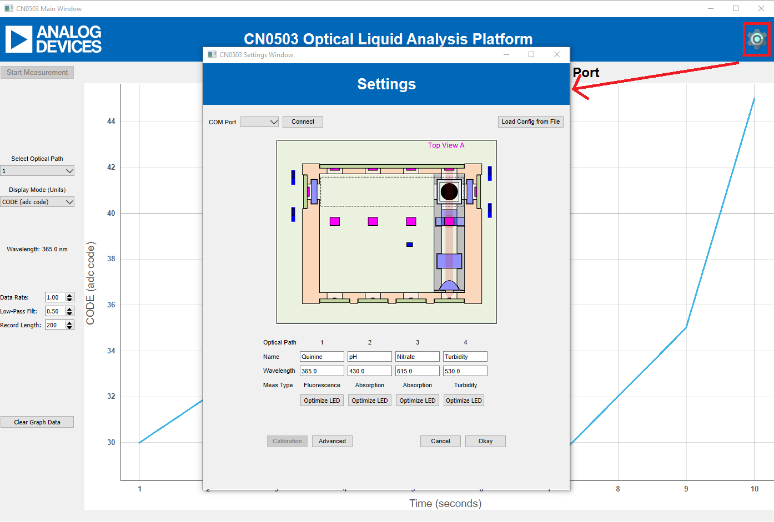
Figure 1. Opening the Settings Window

- Choose the correct port in the window and click connect.
  - If the connection was successful, the GUI reads the config from the device and the terminal window should show text like the following.
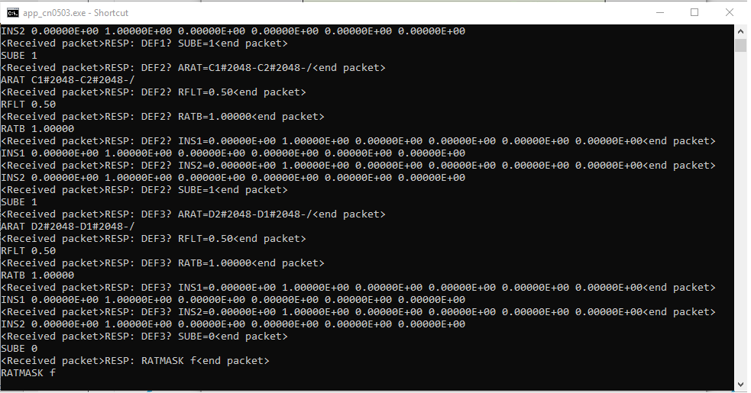
Figure 2. Printout when connected to device
  - If the appropriate COM port is not shown in the dropdown, then it was not in the list of available ports when the settings window was opened. Make sure the port is plugged in and not in use and reopen the settings window to refresh the list.
- Close the settings window by clicking Okay.

- Click Start Measurement to start reading data
  - While in operation, the Select Optical Path can be changed to show data from the different optical channels on the CN0503.
  - While not measuring, other measurement settings can also be set, such as:
    - Mode: Direct ADC Code (CODE), Absolute Ratio (ARAT), Relative Ratio (RRAT), Instrumentation Polynomial 1 (INS1), and Instrumentation Polynomial 2 (INS2). For detailed descriptions, see the CN0503 firmware wiki
    - Data Rate: Accepts values from 0.01 Hz to 5.0 Hz. CODE Mode is fixed at a higher rate.
    - Low-Pass Filter: This is a per-channel digital low-pass filter decoupled from the data rate. Make sure you are on the correct channel before setting
    - Record Length: How many data points to store before the graph starts scrolling. Note that if you intend to export the graph data, it only exports the data that is currently on the graph, so this also limits the export data points.
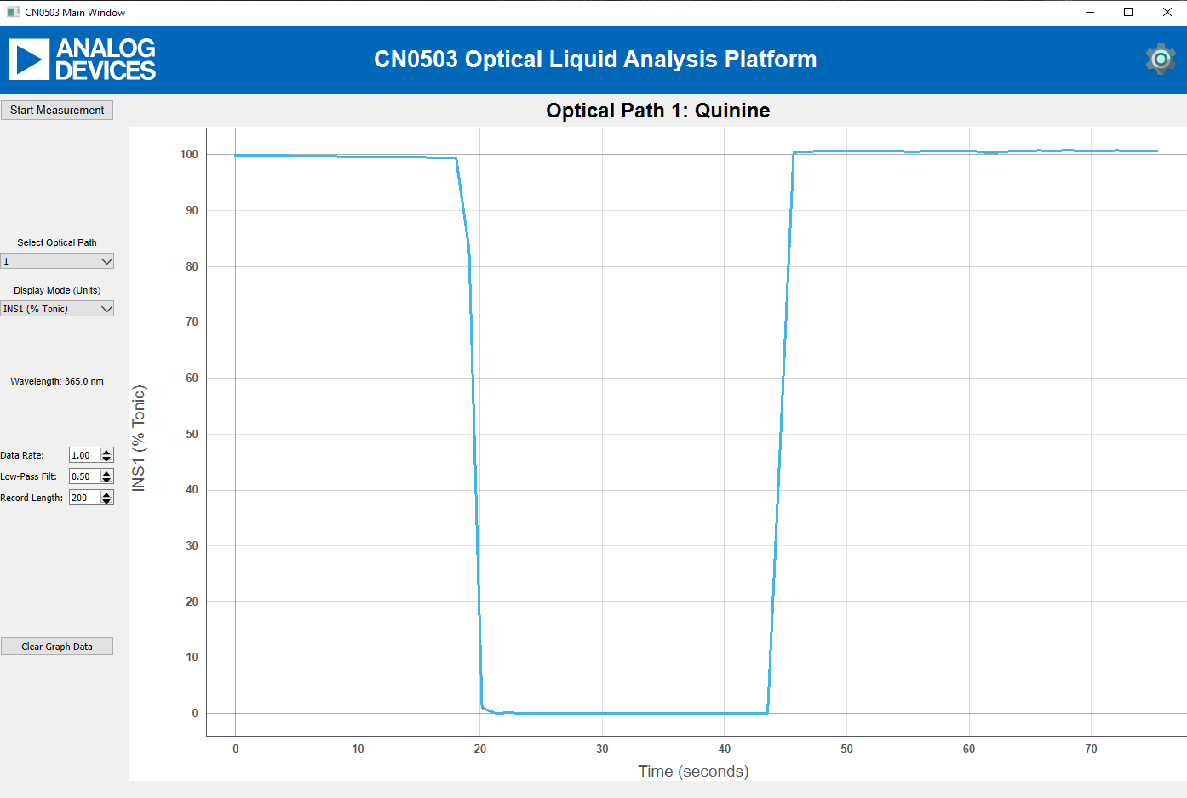
Figure 3. Example measurement window after a polynomial calibration

- Click on Stop Measurement and export graph data by right-clicking on the graph and choosing Export
  - If there is good data to export on multiple channels, data from each channel will have to be exported separately. This is different from the terminal interaction, where the data from all channels is printed out at the same time.
    - Data is taken for all channels while the system is measuring, but data is only displayed for one channel at any time. Therefore, you can run 4 measurements in parallel. Switching between channels/optical paths during or after the measurement will not erase any of the data. However, switching the mode or starting a new measurement will clear the data and graph. When the record length is reached, the oldest measurement is removed from the graph each time a new measurement point is acquired.
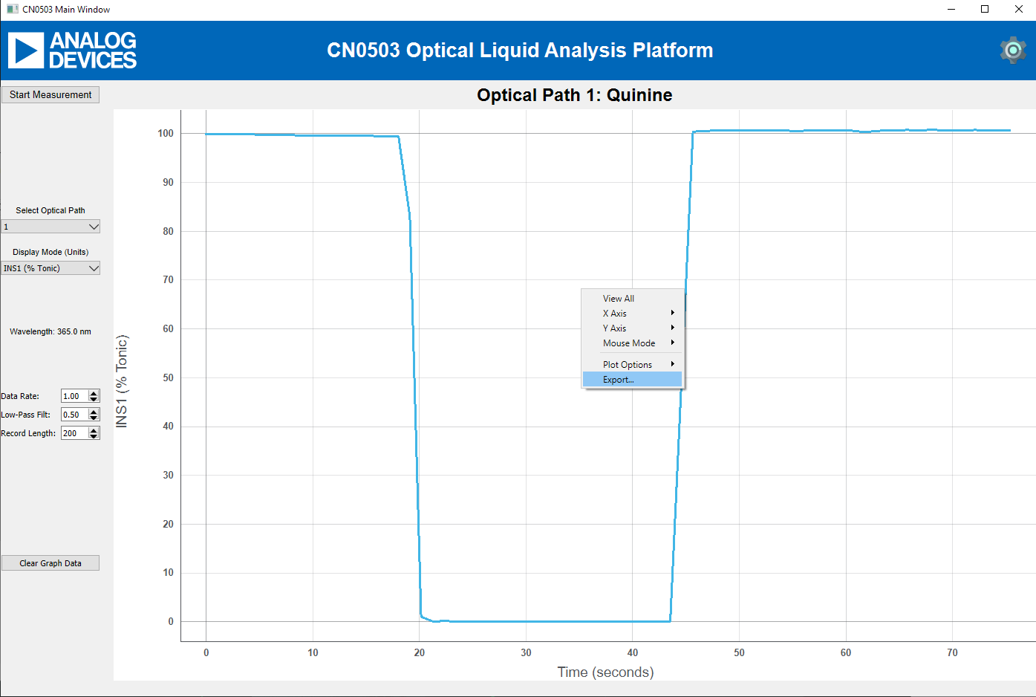
Figure 4. Exporting data from graph to csv

Additional Functions

Configuration Files
- The GUI Settings window allows loading a config file. While not strictly necessary, this can be useful for changing configurations. Config files may consist of register writes to the ADPD4101 (either using the REG command or just the hex address and hex value) as well as application settings commands including MODE, ODR, DEFn, and RATMASK. An example config file is provided with the default configuration.
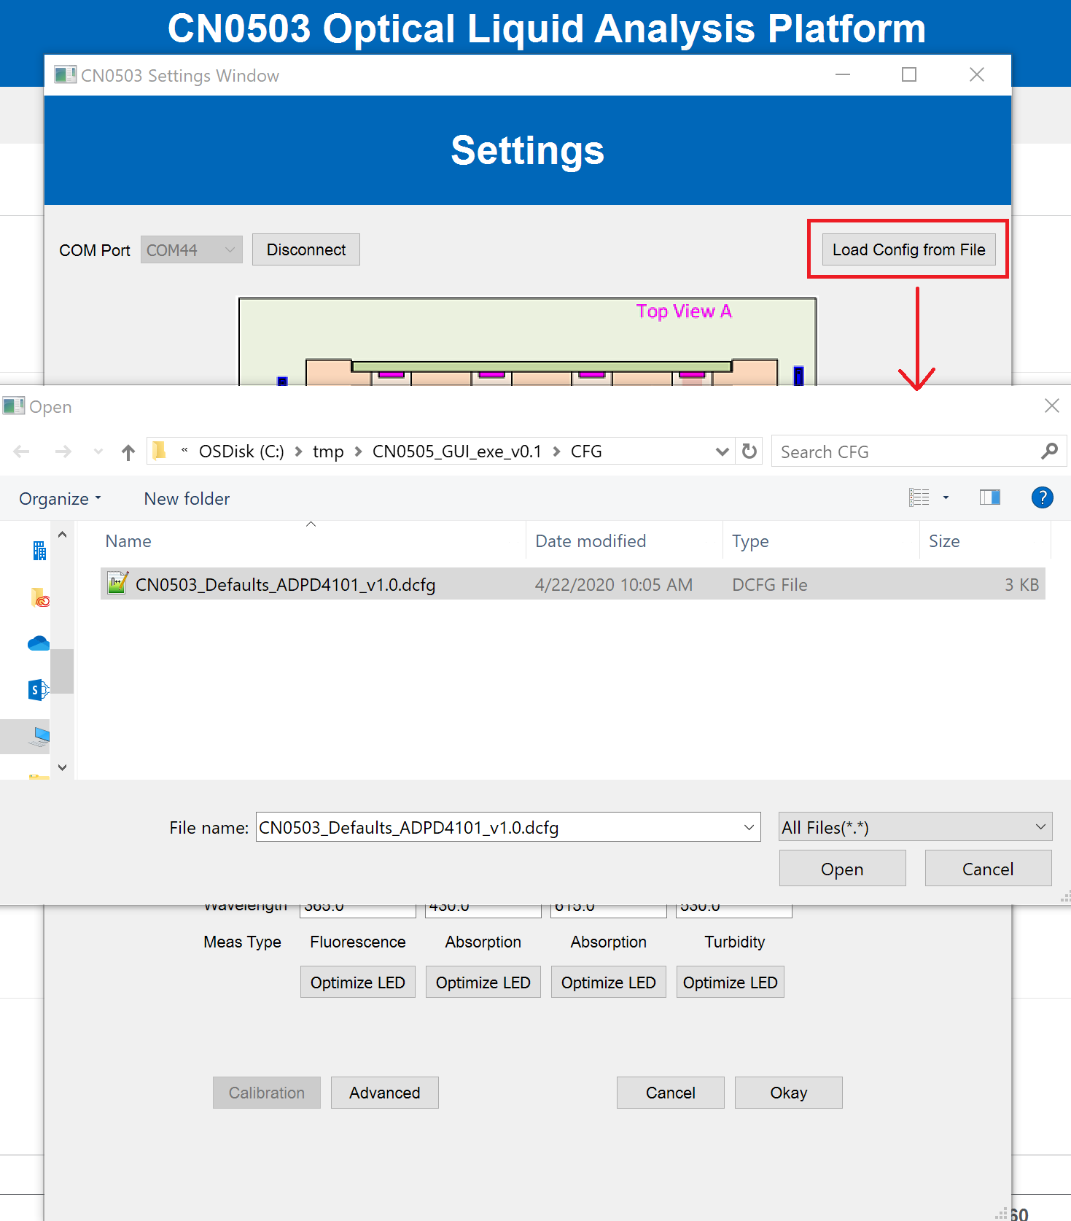
Figure 5. Loading a config file
- After loading a config file, the system will be in the new configuration. The GUI will prompt whether to also program that config to user flash. If it is written to flash, the CN0503 will power on in that state by default in the future. The original state can be returned by loading the manufacturer defaults flash page or loading the default config file.
- It is also possible to use the GUI to load a configuration file, then exit the GUI and stream/log data with a terminal program if that’s preferred.
- Included config files:
  - CN0503_Defaults_ADPD4101 – Same configuration as default power-on. Mainly included to easily get back to the default config if the flash has been programmed with another config.
Note: This config assumes the default LEDs mentioned in the wiki and the intro of this document. Mainly, the 365nm LED in channel 1 for fluorescence required higher current drive. If changing LEDs, make sure to use the Optimize LED Current option.
    - V1.1: Fixed a crosstalk issue in config timing.
  - CN0503_Afe-swap-mode_ADPD4101 – This config was based on the default v1.1, but uses an additional time slot per measurement to cancel AFE errors and low frequency noise. The drift is lower and the SNR is higher in this config.

Saving changes as a config file
- After making changes to measurement setups, those changes can be saved as a config file so they can be reloaded later or loaded on another system.
- The system keeps track of the changes made to configuration settings and register values since the GUI started. Saving changes to config file will only save these changes.
- If it is desired to save a full configuration that doesn’t rely on the initial configuration before the GUI started, first load the default configuration file, then make the necessary changes, and then save the changes to a config file. The result is a config file that has the default configuration plus any changes made after it was loaded.
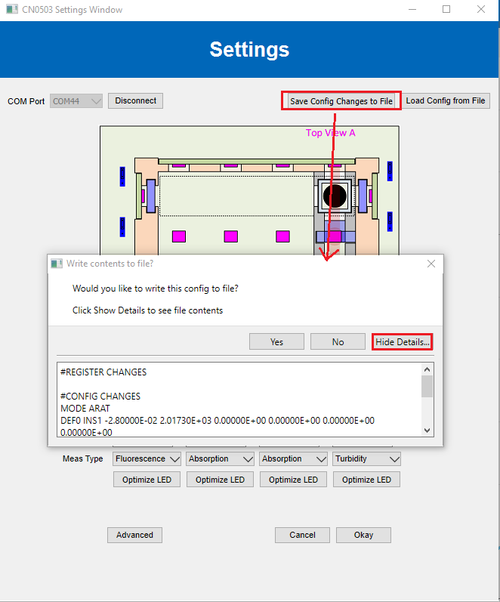

Set Measurement Type
- The default measurement of each channel can be changed using the dropdown menu in the Settings window. This sends a command that sets default values for ratio math (configuration settings ARAT, RATB, and SUBE) and default LED drive values.
- After changing the dropdown to change the measurement type of one of the optical paths, it is recommended to make sure the jumpers and LEDs on the board are correct, place a sample holder with a blank sample in that optical path, and run the optimize LED Current button.
- The updated configuration can be saved as a configuration file using the Save Changes as Config File option.
- Optical Paths 2 and 3 are only capable of the Absorption setting because they do not have a 90° detector needed for Fluorescence and Turbidity measurements.
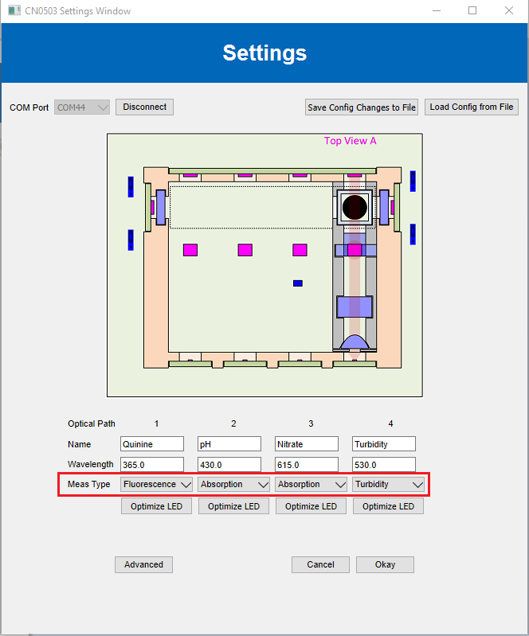

Optimize LED Current
- The LED currents can be optimized to maximize the SNR without saturating the ADC. Before running this command on a channel, a cuvette holder with a blank or distilled water sample should be inserted in that channel so the light levels hitting the photodiodes are the same as they would be during a measurement.

Advanced Settings
The Advanced Settings window can be used to set up units and ratio equations, manage the flash, and send direct commands to the CN0503.
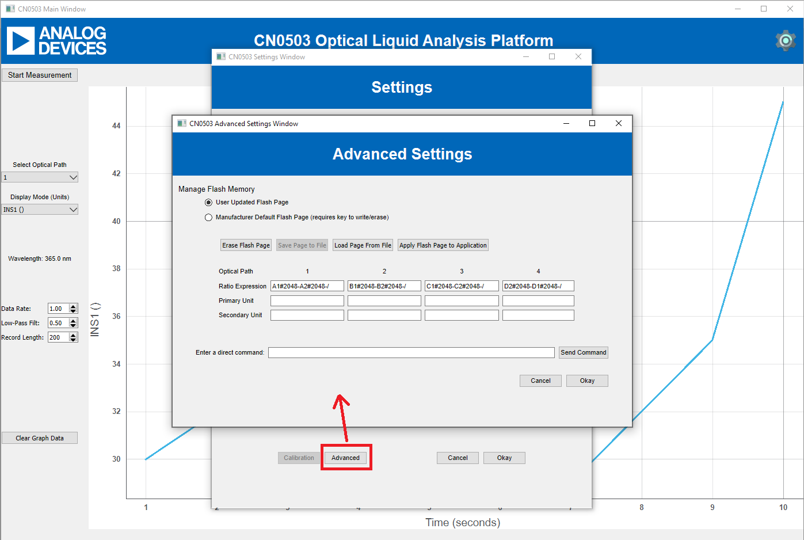
Figure 6. Advanced Settings window
- Managing the flash page contents: 2 pages of flash are reserved for configuration data. Page 1 is the manufacturer defaults page, which stores the default configuration and settings. Page 2 is the user updated configuration page, which can be used to store full configurations or just the changes to be applied on top of the default config. The advanced settings window allows erasing either flash page, loading a flash config from file (in the same format as the normal config files), or applying either flash configuration to the application). Writing to or erasing the manufacturer defaults page requires a key (which is currently 15091994).
- Ratio Equations: See CN0503 firmware wiki. Ratio equations are Reverse Polish Notation (RPN) expressions to define the math to convert ADC codes into floating point ratios between channels. These expressions can be more complicated, but are typically a digital offset-compensated version of the measurement PD reading divided by the reference PD reading.
- Units: For each channel, the DEFn INS1 polynomial is an up to 5th order polynomials used in the firmware to convert between relative ratio and a primary unit value to print in INS1 mode. The DEFn INS2 polynomial is used to convert from the primary INS1 unit to a secondary INS2 unity. Both units can be defined here. The polynomials can be calculated from measurement data and input into the direct command field (in the way that is described in the firmware wiki and the terminal help command).
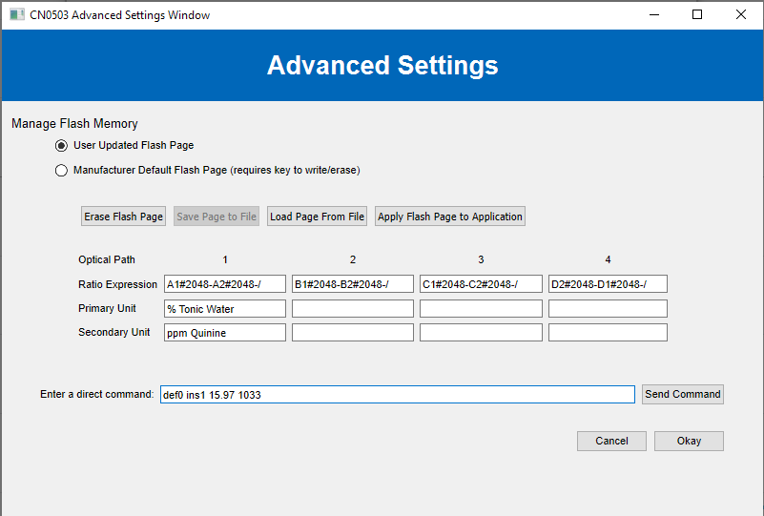
Figure 7. Example of units and polynomial entry in Advanced Settings
- Direct command field: Can be used to send direct commands to the CN0503 as you would on the terminal.

