LOGIN:
Username: admin
Password: analog

SYNCHRONA STATUS:
In the right top corner two statuses are available:
- connection status (connected/disconnected) tests if there is a connection with the board and if the current hardware configuration is valid (HMC7044 and AD9545 are required)
- devicetree status has three states:
- ‘No devicetree loaded’ appears when it could not found a synchrona overlay in the current configuration
- ‘The current devicetree is not loaded’ appears when an valid overlay was founded but it is not applied to the system
- ‘Devicetree loaded’ appears when the overlay in used is applied to the system

GENERAL MENU:
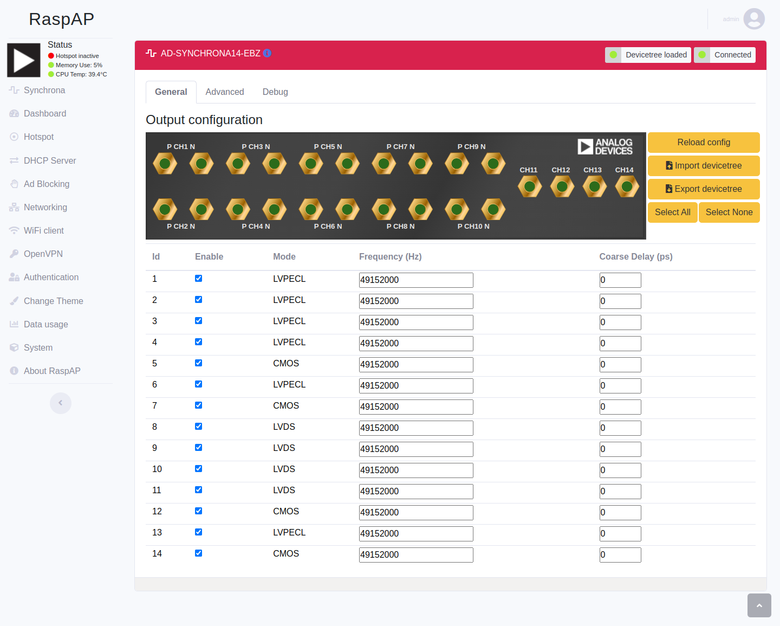

The general menu provides some basic information about synchrona’s channels:
- state (enable/disable)
- mode (LVPECL/CMOS/LVDS): not modifiable
- output frequency: the output value in Hz
- coarse delay: a specific recomputed set of data in ps for the digital delay
In the general menu are exposed the following buttons:
‘Rolad config’ : tests if the configuration is valid and load the afferent overlay
Import devicetree: applies a new overlay loaded from the computer
Export devicetree: downloads the devicetree in use
Select all/ Select none: All selected channels for general menu are changed simultaneously.
A specific set of channels can be selected by clicking on the golden outputs of each channel.
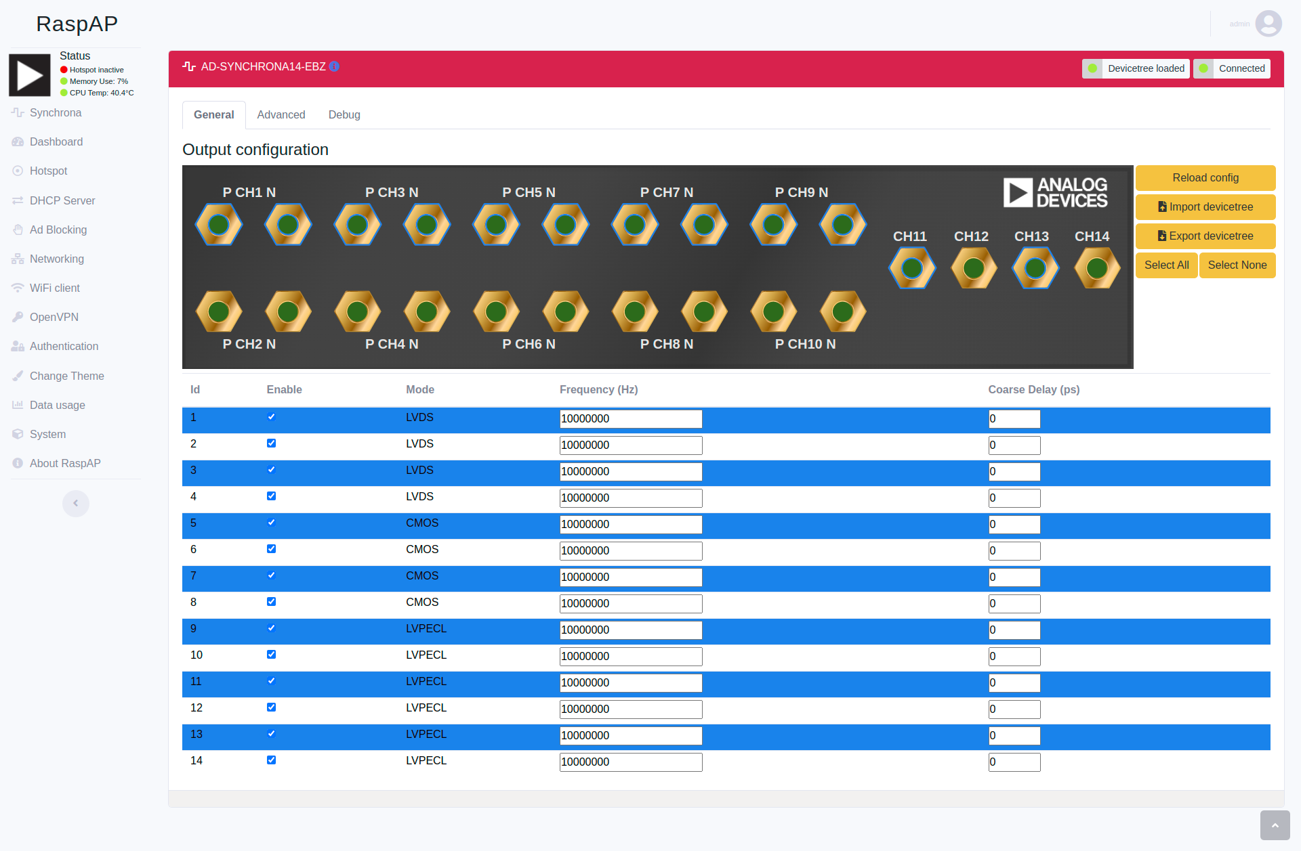

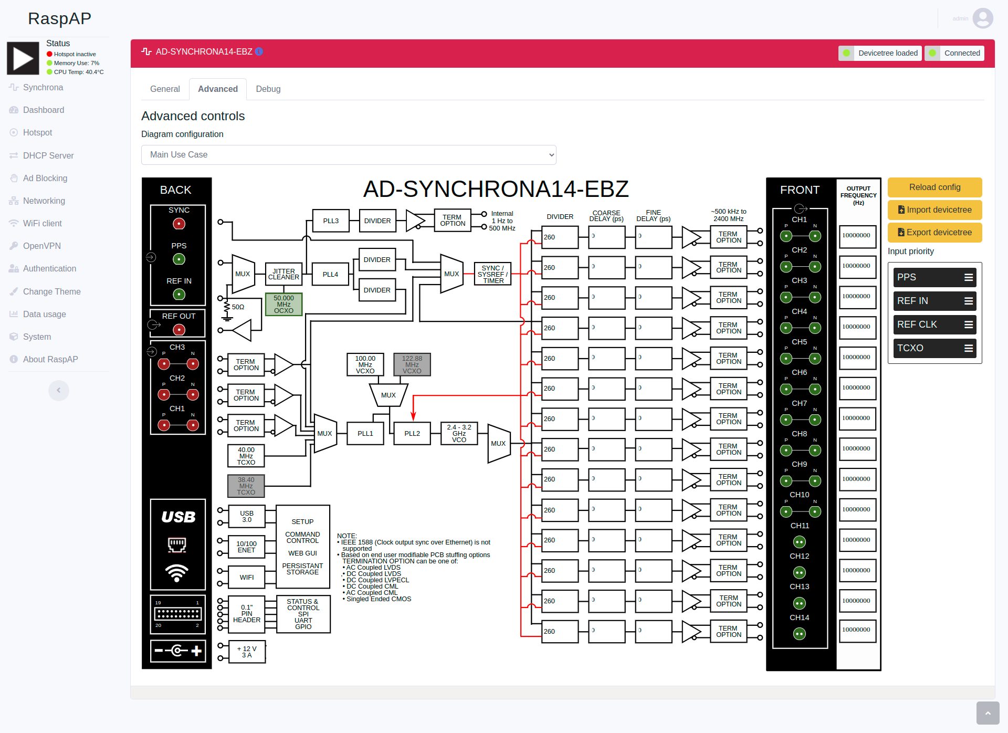
ADVANCED MENU:

The advanced menu provides all the functionality found in the general tab and some more:
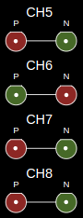
- divider are displays but cannot be changed
- VCXO and TCXO can be switch (not necessarily – the server will try to find a suitable configuration)
- input priority can be specified; available inputs: 1pps, ref in, ref clk (CH 2), TCXO; if no input is connected, synchrona will use the internal reference
- coarse delay, fine delay, output frequency (each in the afferent column)
For channel 5, 6, 7, 8 single outputs(P/N) can be enabled/disabled

DEBUG MENU
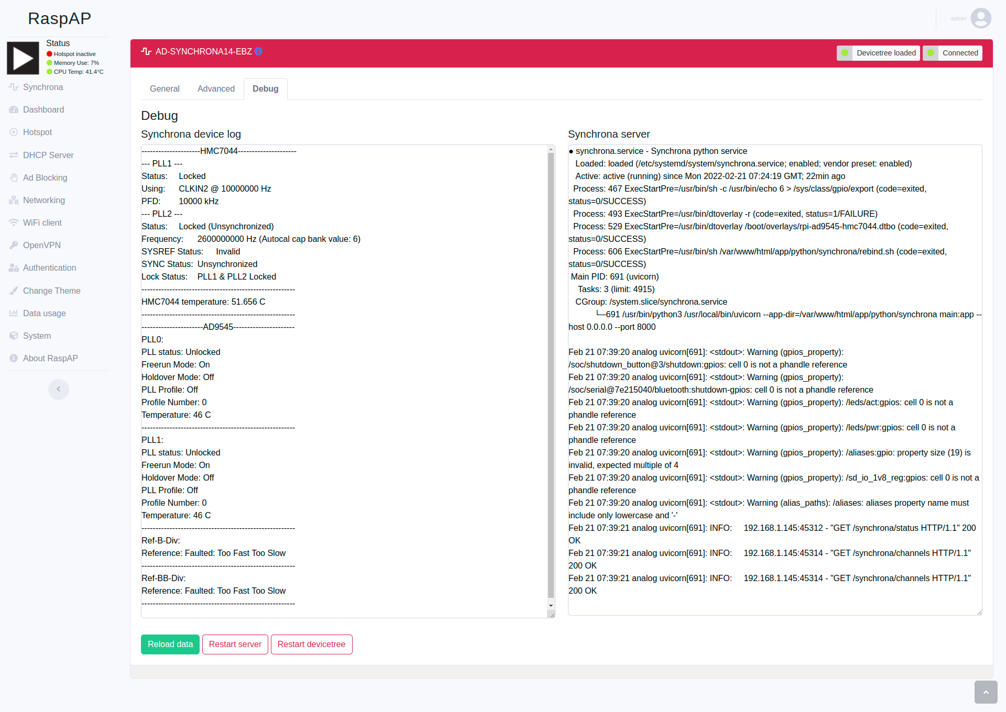
The debug menu contains useful information about:
- hardware status: HMC7044 status, HMC7044 temperature sensor, AD9545 PLL1, PLL2, Ref-B and Ref-BB
- server status (python service used for creating the overlays)
Available buttons:
Restart server – stops the server and restarts it
Restart devicetree – applies and load a standard devicetree
Reload data – reloads the page
For all the other menus check the raspAP official documentation: https://docs.raspap.com/

