AD-SYNCHRONA14 ASSEMBLY PROCEDURE

1st STEP:
Use a threading tap (or a screw) to make the threads for the front and back panel.
Clean the remaining metal debris.
See pictures below.

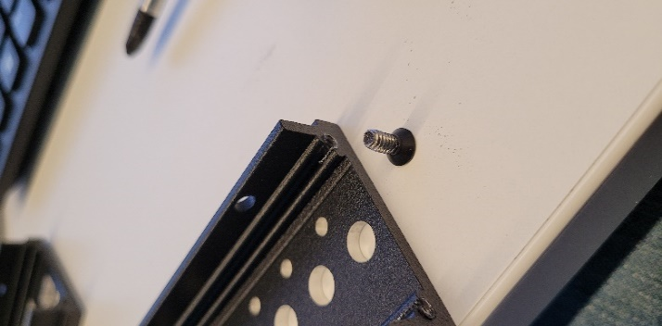
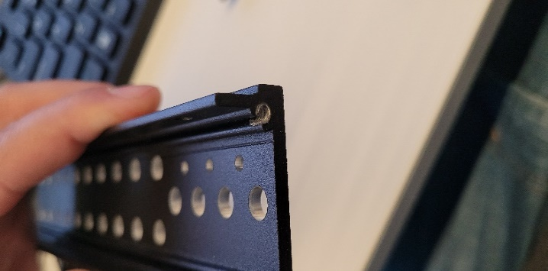

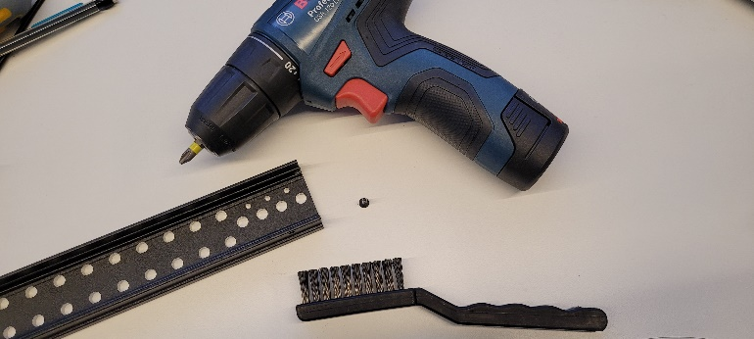

2nd STEP:
Place all the SMA-u.Fl (CABLE 348 RF-050-F4-A-1 and CAB.721) cables into the front and back panel.
There should be 28pcs of CABLE 348 RF-050-F4-A-1 and 2pcs of CAB.721.
!!! The two CAB.721 cables go into the back panel into the PPS and REF IN slots !!!
Use a Torque Screwdriver or wrench to tighten the SMA nuts. Set it at 1.1 - 1.2 Nm.
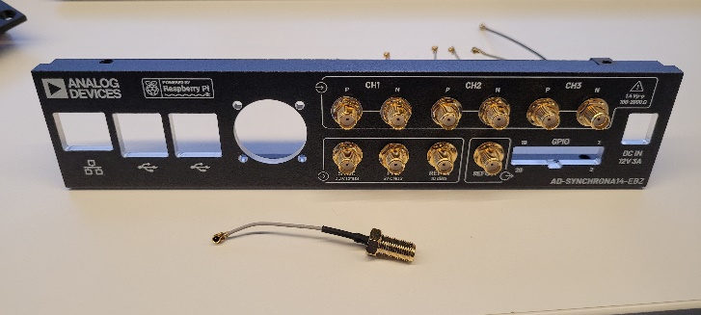
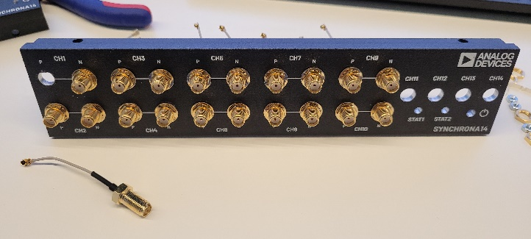
See pictures below.
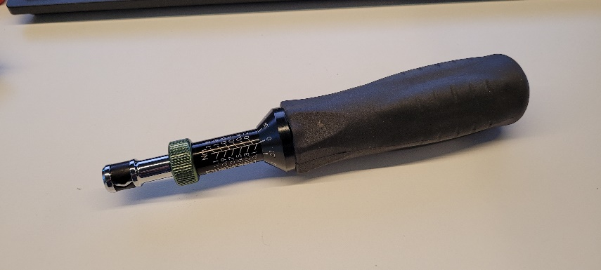

3rd STEP:
Crimp terminals 8550102 to the fan MF25100V2-1000U-A99 wires.
Insert the terminals into connector 22013037:
Pin 1 – NC
Pin 2 – red wire
Pin 3 – black wire
Mount the fan to the back panel with 3 92000A109 (16mm) screws.
See pictures below.
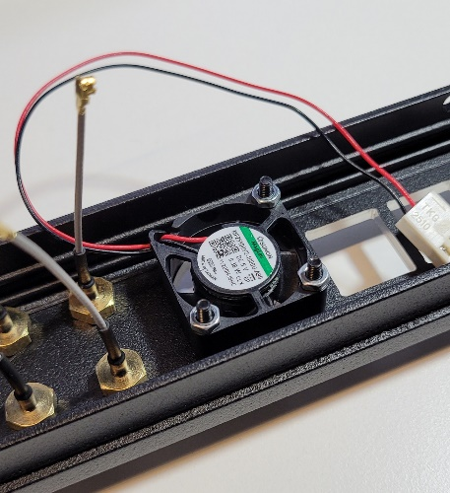
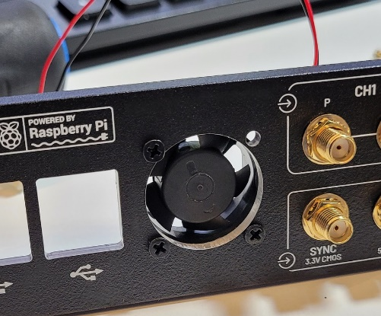
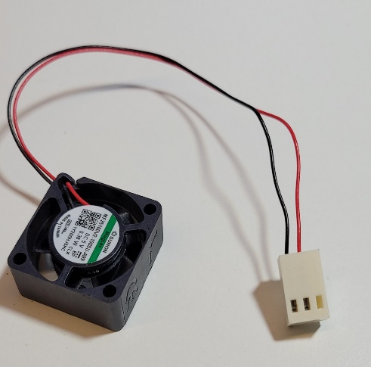

4th STEP:
Place 2, 971110155 11mm spacers on top to hold the Raspberry Pi.
The 11mm spacers will be hold with 971150155 15mm spacers from the bottom. (see picture).
Place 15mm spacers in the remaining mounting holes except for the ones near the Raspberry Pi connector.
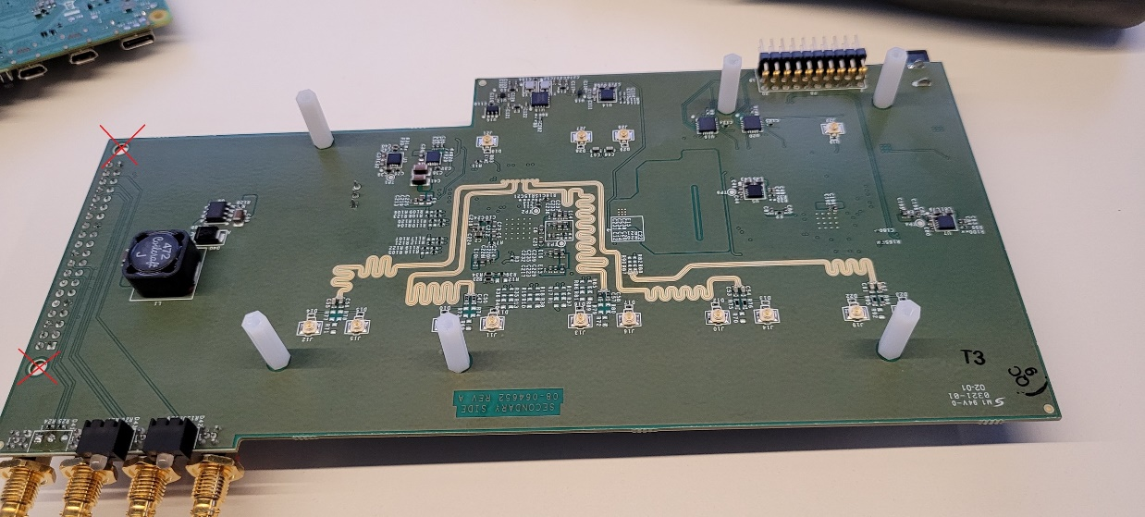
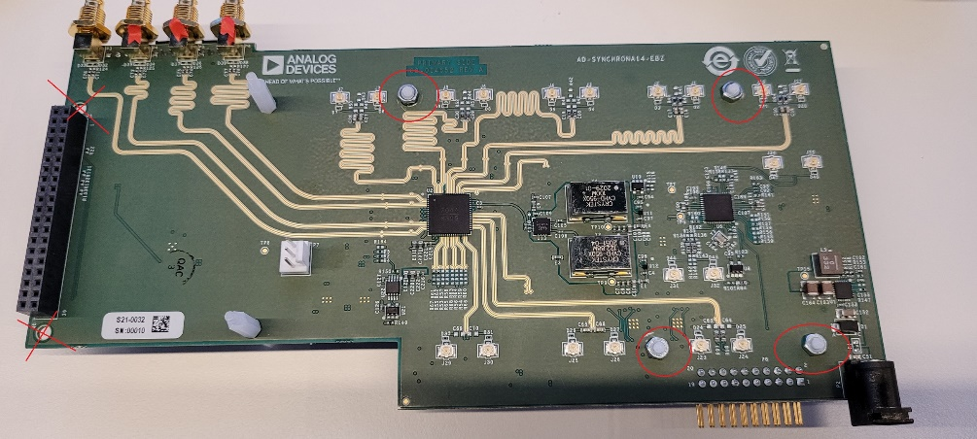
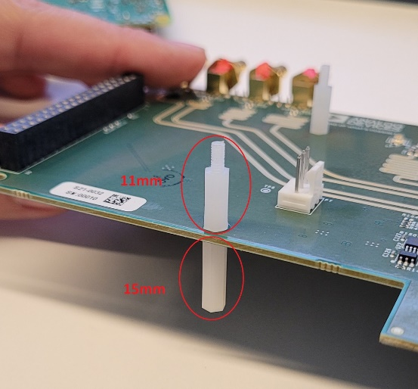
See pictures below.

*these are pictures of rev A board.
*rev B should have a total of 7, 15mm spacers.

5th STEP:
Insert the Raspberry Pi. Place 2 nuts on the 11mm spacers.
Insert the SD card into the Raspberry Pi.
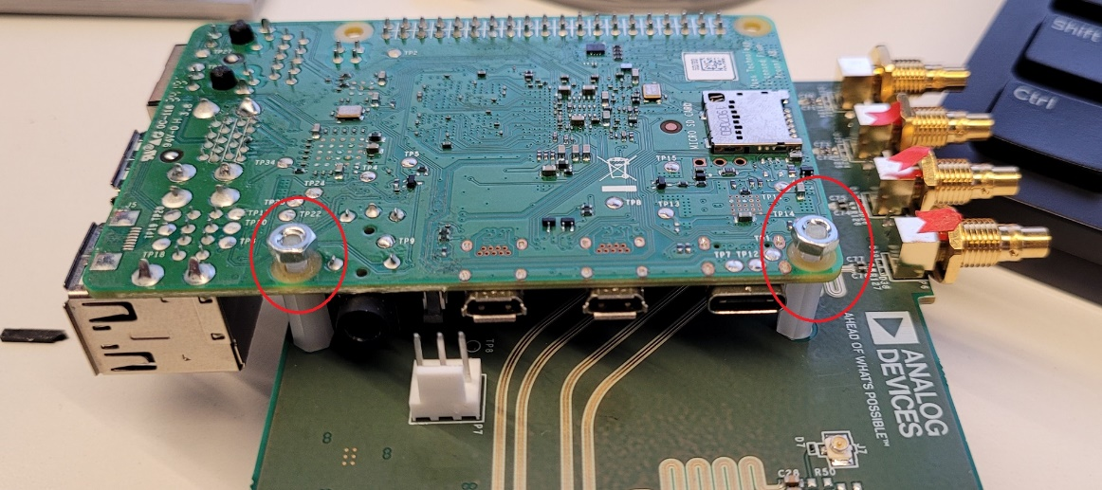
See pictures below.

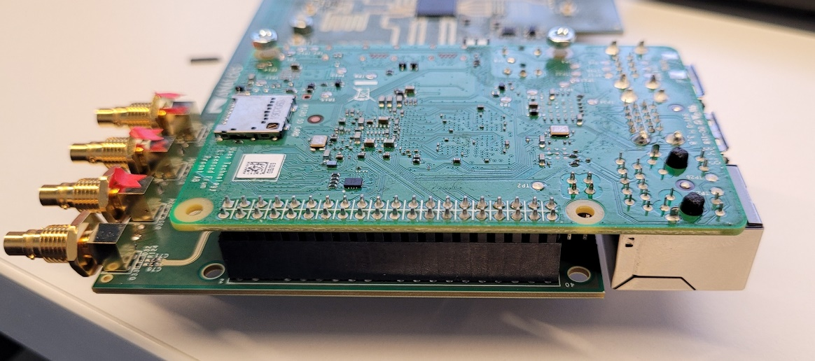

6th STEP:
Insert the board into the front panel.
Fix it with the 4 nuts of the Twinax connectors.
!!! Do not place the washers on these 4 connectors !!!
Use a Torque Screwdriver or wrench to tighten the Twinax nuts. Set it at 0.6 - 0.7 Nm.
See pictures below

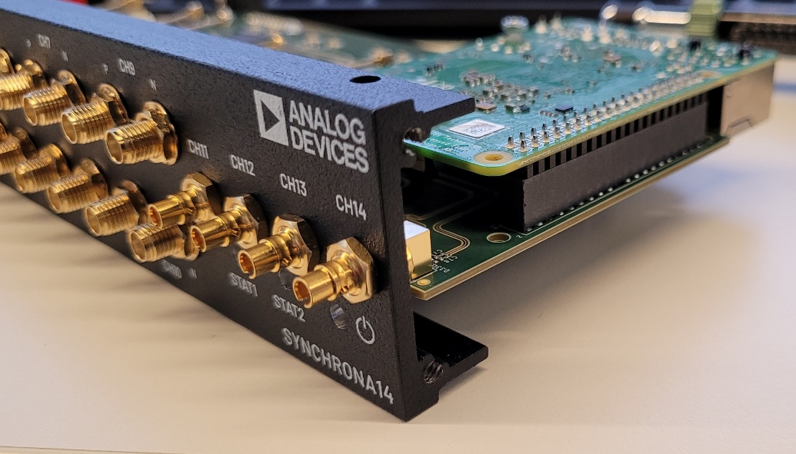

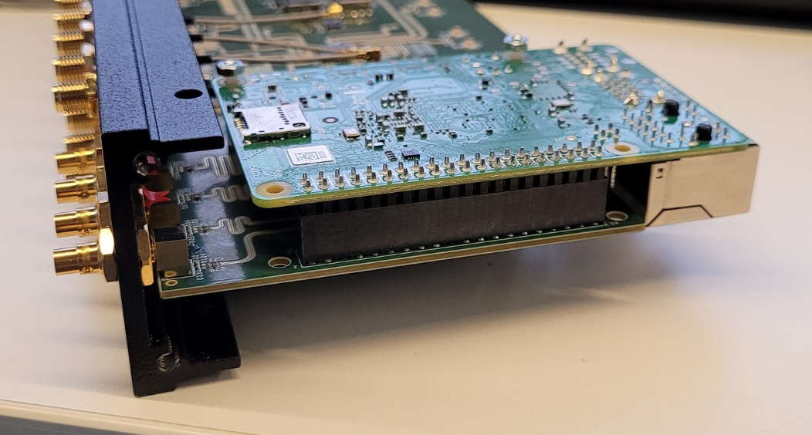

7th STEP:
Insert the u.Fl connectors. Match the designators from the front panel to the designators on the silkscreen.
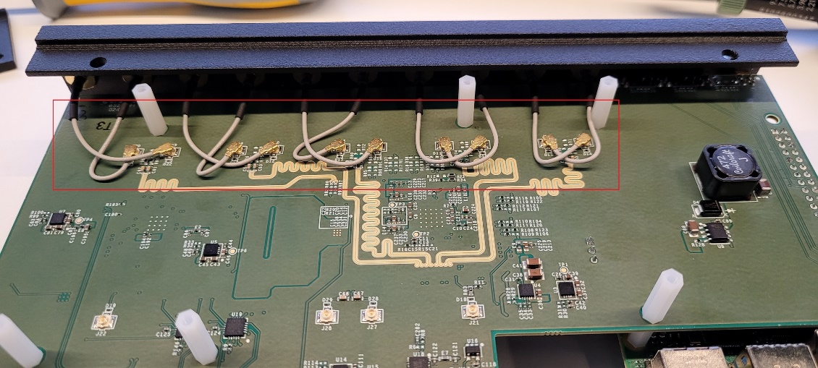
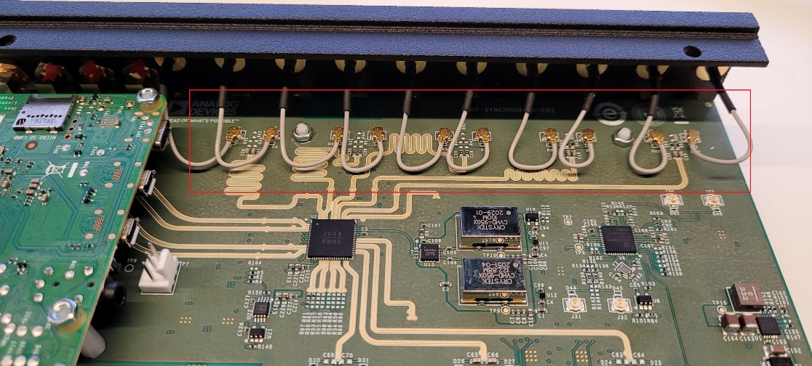
See pictures below.

8th STEP:
Mount the side panels. Place the side panel with the cuts on the Raspberry Pi side.
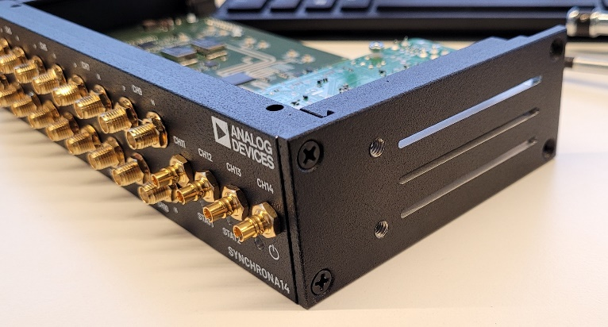
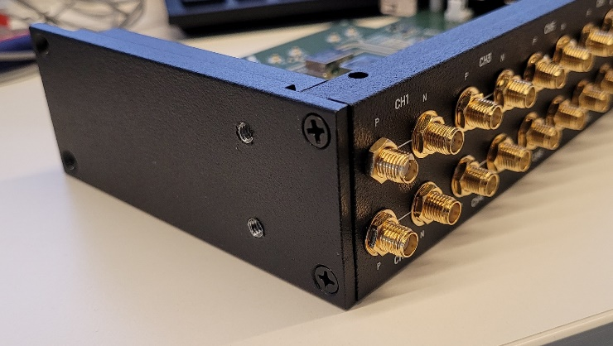
See pictures below.
9th STEP:
Mount the back panel.
Insert the fan connector.
Insert the u.Fl connectors. Match the designators from the back panel to the designators on the silkscreen.
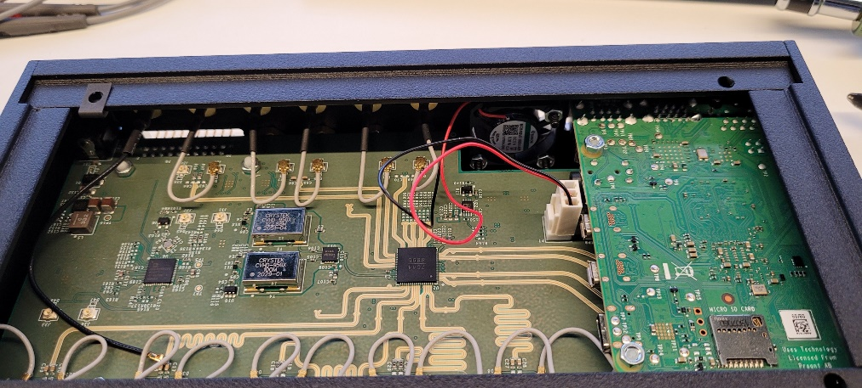
See pictures below.

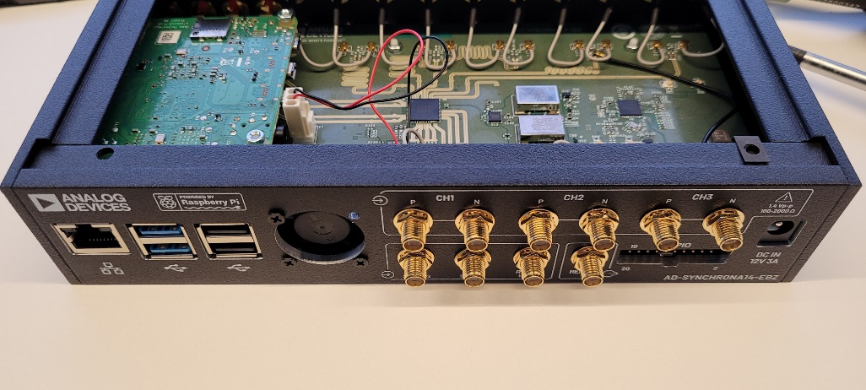

10th STEP:
Place the Heatsink (S1510-10W-T411-10), on U2.

11th STEP:
Place the clip nuts on mounting holes of the bottom panel.
Place the bottom panel and insert the 6mm screws 91801A135 that go into the spacers.
Fix the bottom panel with the screws that came with the Hammond enclosure.
See pictures below.

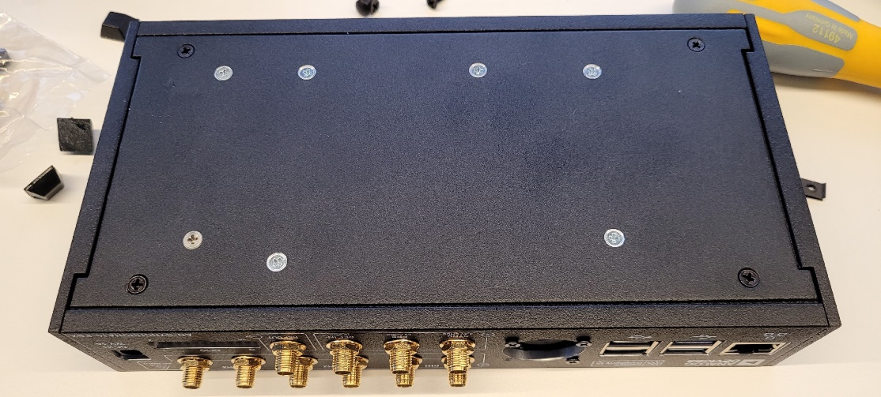
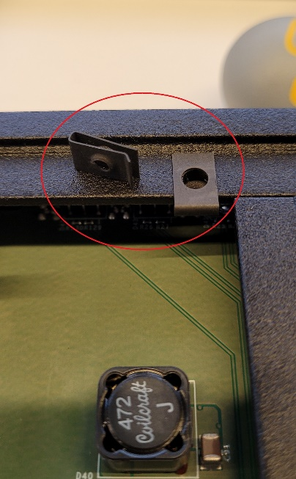

12th STEP:
Place the clip nuts on mounting holes of the top panel.
Fix the top panel with the screws that came with the Hammond enclosure.
